Name__________________________________ Date________ Hour______
Chapter 2 Section 1 Notes
Mesopotamia and Sumer
- The Geographic Setting
  - Mesopotamia
    - Lies between the ________________________ rivers
    - Part of Fertile Crescent, which stretches in a crescent shape from the eastern edge of _________________
___________________________________________
- Tigris & Euphrates Rivers
  - Source ___________________________________
  - Floods brought:
    - ______________________
    - ______________________
    - ______________________

- ___________________________
- Independent cities
  - Shared common __________________________
  - Remained _______________________________
  - Each city acted as a state
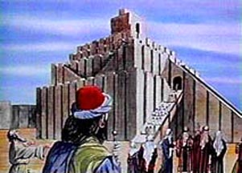
  - Each city had its own
- _____________________
- _____________________
- _____________________
  - Markets were busy places where _______________ ____________________________could be acquired
  - Streets were crowded
  - Houses faced inner courtyards, where family life took place

III. _________________________________
- Temples
- Sites of ___________________________________
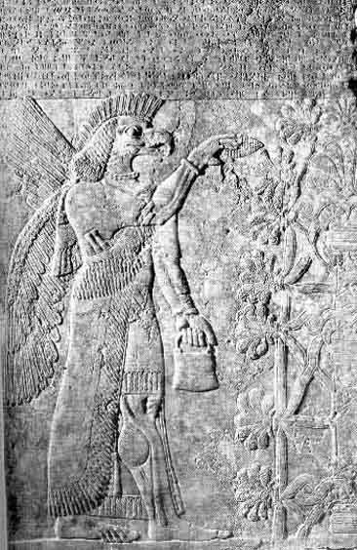
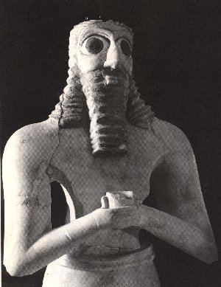
- Built as __________________
- Religious beliefs
- People believed ____________________________
- Myths or stories about gods explained people’s beliefs
- The gods
  - _________________________________________
  - ______________________ were offered to the gods
- The fall of Sumer
  - _________________________________________
  - City-states conquered and ___________________
_________________________________________
